**Figure S1** – Histograms showing distribution of when caterpillars were reared over the duration of the experiment. (a) All data, across years, pooled together. Note that the majority of caterpillars were measured between mid-July and mid-September. (b) Data broken down by monarch population and experiment year. Note that the populations from Guam (GU) and Puerto Rico (PR) were only tested in 2018. To account for possible effects of changing plant condition over the duration of the experiment, some populations were reared across the length of the experiment (i.e. ENA in 2017 and CA in 2018).

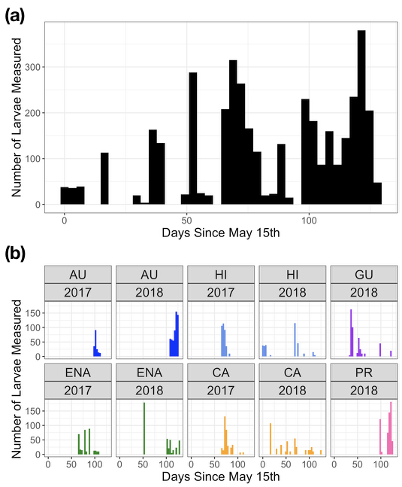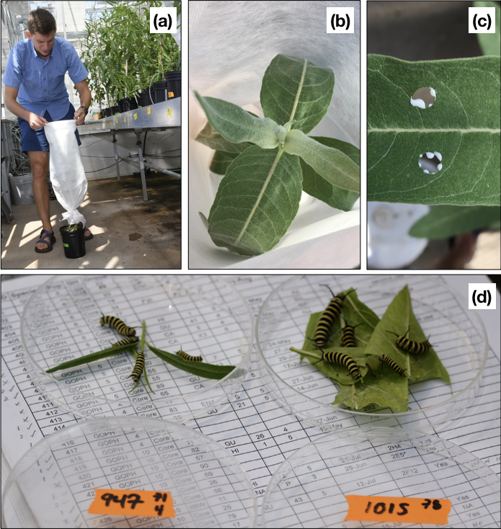

**Figure S2** – (a) Example of mesh bags used to enclose plants. The base of the bag was tied using metal twist ties; the top of the bags was kept sealed using binder clips. (b) View inside of mesh bag enclosing an *A. speciosa* plant. (c) Latex sampling from *A. speciosa*. (d) Example of recording caterpillar mass on day eight. In this picture, caterpillars are from the Puerto Rican population and plant 947 (*A. fascicularis*) and plant 1015 (*A. curassavica*). Note pronounced size differences between plant species.

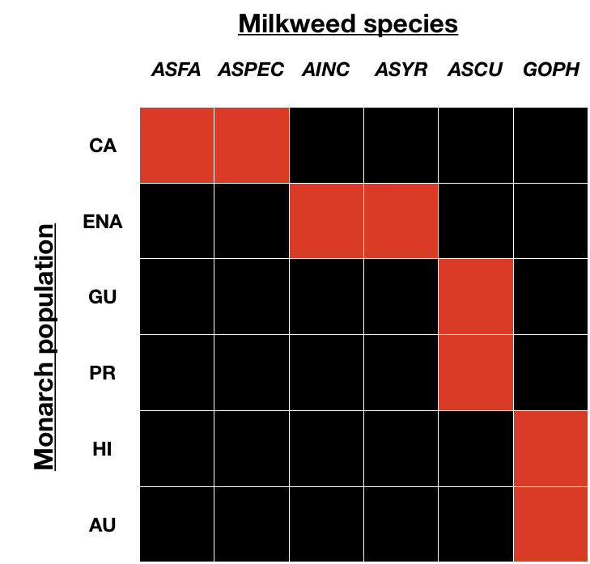

**Figure S3** – Visual representation of experimental design. Each cell represents a unique combination of monarch population x host plant species. Cells in red correspond to sympatric combinations; cells in black are allopatric combinations. The experiment was fully reciprocal, with every possible combination tested. The local adaptation effect summarizes the magnitude of the difference between mean performance on sympatric and allopatric combinations.

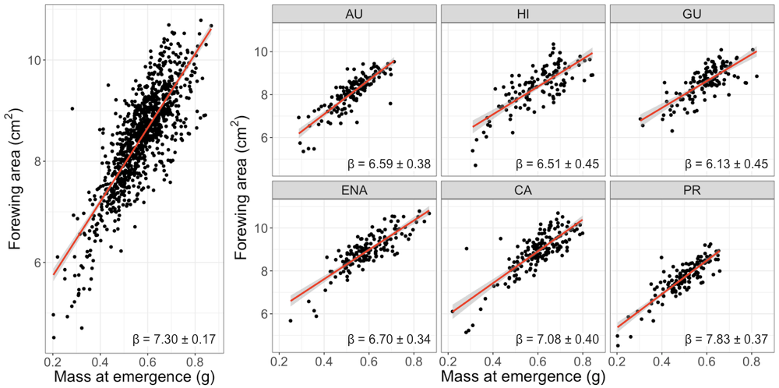

**Figure S4** – Correlation between eclosion mass and forewing area. Panel at left shows all data pooled together, while panels at right are split by monarch population.